

**Effect of Geopolitical in Eurozone Banking**

Name: Gadepalli Vighneswara Sai Saroja Vaishnavi

University of Kent

Student ID: 24049518

Module Code: BUSN9006

**Abstract:**

This dissertation examines the impact of geopolitical risk (GPR) on the stability and profitability of the Eurozone banking sector. Utilizing a comprehensive dataset spanning from 2012 to 2021, this research employs econometric models to analyze the relationships between GPR and key banking indicators such as Z-Score, Return on Average Assets (ROAA), Return on Average Equity (ROAE), and Non-Performing Loans (NPLs). The findings reveal a significant inverse relationship between GPR and bank stability, with heightened geopolitical tensions leading to lower Z-Scores, indicating increased vulnerability to financial distress. Additionally, GPR is shown to negatively affect bank profitability, as evidenced by declining ROAA and ROAE, and to exacerbate credit risk, reflected in rising NPL ratios.

The study also explores the differential impact of realized geopolitical risks versus perceived threats, demonstrating that actual geopolitical events have a more profound effect on bank stability and performance. Furthermore, the research highlights the importance of robust risk management practices, suggesting that banks with higher equity ratios and more effective credit management strategies are better equipped to withstand the adverse effects of geopolitical risks. The implications for policymakers include the necessity of implementing macroprudential policies that account for geopolitical uncertainties and fostering international cooperation to mitigate the destabilizing effects of geopolitical tensions on the financial sector.

This dissertation contributes to the existing literature by providing empirical evidence on the impact of geopolitical risk in the Eurozone context, offering valuable insights for bank management, regulators, and policymakers on enhancing financial stability and resilience in an increasingly uncertain global environment.

**1. Introduction:**

1.1 Introduction:

Geopolitical risk is one of the imperative factors to determine the investment strategies for banks. Geopolitical risk can be defined as any risk that could potentially develop due to political instability, wars, tensions arising between different countries, terrorist attacks any other event that could potentially disrupt the international relations between countries. This is a major risk that needs to be considered as it might lead to an economic instability which could potentially lead to systematic risk all over the world as pointed out by studies by Balli and Louis (2019) and De Haan et al. (2020). Geopolitical risk is very complex and careful considerations have to be taken because the source of this risk not only emerges from disturbed relations between two countries but also the effect of these disturbances should be considered on the rest of global banking. Geopolitical risk has a ripple effect and can be seen in countries that no direct relation to the risk. Therefore, further study, research, disciplinaries are important to understand the risk and its effects.

Eurozone is considered to be one of the central locations for trade worldwide and any impact could lead to shocks that can be passed to the other regions of the world. Over the past few years, there have been significant changes in the geopolitical events globally which have affected lot of regions including the Eurozone. These geopolitical events can range from Brexit to the Russia-Ukraine war and also change in government policies, sanctions or conflict of interests which could lead to trade disruptions and instability in commodity prices. In research done by Hai Hong Trinh and Thao Phuong Tran (2003), it is observed that in 158 economies there has been a negative trend in geopolitical risk and financial stability of banks in those regions. Here Z-Scores have been used as a proxy for the banks performance and it was proved that 1% increase in the geopolitical risk in a year has led to 0.116% decrease in Z-Scores of banks worldwide. In another study done by Yıldırım, F. and Berkman, A.N. (2022) which follows Driscoll-Kraay’s Fixed Effects Model (FEM) estimator it is shown again that geopolitical risk and bank’s performance have negative relationships. Driscoll-Kraay’s Fixed Effects Model (FEM) Driscoll, John & Kraay, A.C.(1998). estimator is a statistical method used for panel regressions and it considers cross-sectional dependence, autocorrelation and heteroskedasticity by adjusting the robust standard errors.

1.2 Recent Developments in Geopolitical Risk:

Geopolitical risk can be one of the biggest risks which can require a huge write-off. With uncertain geopolitical events happening around the world and the impact it has on the economies is something to be considered. There were major geopolitical events in the past such as the Brexit, Russia-Ukraine war, unrest in Israel and Palestine which shape the international laws for business which in turn effects the overall economies and performance of the banking sector. For example, the Russia-Ukraine war had a significant impact on food and oil prices in Eurozone, all prices went up by 47% of staple foods (European Central Bank 2023). In many parts of the world, there were financial sanctions on Russia which included no trading and Russia’s banishment of Russian banks from Society for Worldwide Interbank and Financial Communication (SWIFT) which is used by most of the financial companies to send information and wire transfer in a secured channel and is governed by the central banks of G10 countries including European Central Bank (KPMG 2022). There has been an overall increase in the firms reporting losses in the European Union according to Lefort, J.S in the article Ukraine economic shock. It is also reported that 30% of the bank’s loans are at risk. The tensions between the US and the China are also noteworthy as it might lead to major disruptions in the world trade and potentially disrupt the banking system in Eurozone (Goulard, S 2022). While these are few of the many developments in the international relations and the geopolitical world, it can help us facilitate our study on Eurozone banks.

1.3 Regulations and Risk Management:

Eurozone banks like all the other regions of the world face a lot of geopolitical risk and have adopted a lot of regulatory frameworks to mitigate geopolitical risk. In research done by Buch and Goldberg (2001) it is shown that geopolitical risk and bank stability have a direct relationship in shaping the bank globalization. It highlights how the borders are interconnected and arguments have been made that regulatory frameworks should evolve according to time and should help banking performance all over the world. There are very specific risk management techniques that ae being followed to mitigate geopolitical risk and methods like stress testing, scenario analysis and regular assessments for geopolitical risk can be very useful mitigation techniques (Cerutti et al. 2020). Research by Claessens et al. (2019) emphasised how sanctions and trade disputes among the rest of geopolitical risks require a timely regulatory response. It also focuses on how regulatory measures should look over bank’s profitability, risk bearing behaviour and cross-border lending. There is a tipping point to balance financial objectives and initiation of international trade and investments.

Moreover, Goodhart and Segoviano (2019) points to the role of central banks in mitigating geopolitical risk by new monetary policies. It also helps us understand central banks can help influence decisions and market sentiments and help improve banking performance. They also give insights on how central banks have an important role to protect the rest of the banks from geopolitical shock waves. Therefore, regulators have a vital role to bring up proactive measures to improve banking stability. The frameworks, policies, risk management strategies, central bank interventions help in absorbing the geopolitical shocks.

1.4 Eurozone and its History of Formation:

Eurozone is a group of 19 different member regions of the world which have adopted Euro as their tradable currency and has been fully incorporated into the local financial system. The 19 countries are Spain, Slovenia, Luxemburg, Austria, Cyprus, Belgium, Germany, Finland, Greece, France, Italy, Ireland, Estonia, Netherlands, Malta, Portugal, Lithuania, Latvia, Slovakia. There was a treaty in 1992, called the Maastricht Treaty (European Union, 1992, Art. 5) which led to formation of one financial system with one currency in the same geography. It is important to know that not all the nations from the European Union are a part of Eurozone, there are nations with independent currencies. Eurozone is considered to be largest economic geographies and the currency Euro is the most liquid currency in the world. There are requirements to join the Eurozone which depend on stable prices, sustainable financing, convergence durability and stable exchange rates. Long term interest rates must not exceed 2% of three member states.

1.5 Eurozone and Geopolitical Risk:

In an online article published by European Central Bank by Dieckelmann et.al (2024), we get to know that Eurozone is facing difficulty maintaining financial stability. A risk that was identified was the tension between US and China over the Taiwan region. Another risk which was identified was Russia-Ukraine war. Any changes in the geopolitics are seen as sign of increased instability in the markets and a huge change in investment decisions of the investors. In 1970’s there was tensions in the Middle East which led to steep increase in oil prices which had severe impact on the oil prices. Another point that is highlighted in this article is that higher geopolitical risk can lead to increase in inflation and could mean reduced profits for the companies in the region that are facing geopolitical risk. This would translate to higher credit risks for the banks, altering the and reducing the bond and equity spreads which would in turn increase the interest rates. It is observed that EURO STOXX 50, which is the Eurozone index falls by 1% when it exposed to 1 standard deviation of geopolitical risk. In a research done by Iversen et. Al (2016) it is discussed that there is no common Eurozone banking system which could lead to bank failures.

**2. Literature Review**

2.1 Quantification of Geopolitical Risk:

There is no method to linearly quantify geopolitical risk. The only information that is prevalent is the geopolitical risk indices that take into account a lot of economic as well as non-economic factors. The indices are quantified by news and alleged information and there is no straight method to calculate the geopolitical risk and its impacts on banking. It is seen that during a geopolitical tension, the price of safter investments like gold, bonds and defence company stocks go up. In a study by Bettin, G., Mensi, G. M., & Recchioni, M. C. (2023) to measure the overall risk of the Eurozone, there is a factor called Geopolitical Factor for Eurozone (GFE) which has been derived from looking at the prices and returns in two different kinds of investments. The first type is where they look at a price and return on gold and defence stocks. Secondly, short positions in UCITS ETF or the iShares S&P 500 Euro Hedged ETF’s are taken in to consideration which means that it will expose all the industries that are sensitive to geopolitical trade and international trade. Interesting part about this paper is that the gold tracking ETF gives price of the gold in US dollars and also compares the ETF’s in Euros which reflects a price differential in both the currencies. The long position in GFE is the average between gold and defence stocks while the short position comes from shorting the industries sensitive to geopolitical risk. The entire GFE comprises of 50% average daily return of PHAU and the other 50% in SXRARO and is subtracted by the IUSE ETF. This is then added back to other risk factors.

2.2 Dominant Research Methods:

We know how geopolitics effects different economies. The main aim of this paper is to prove statistical significance of geopolitical risk and the performance of Eurozone banks. It is shown that one standard deviation increase in geopolitical risk would have a negative impact on the return of stock in the range of 10.53% - 42.14% (Maria-Eleni K. Agoraki, Georgios P. Kouretas & Nikiforos T. Laopodis 2022). There is also an evident relationship between the geopolitical risk and environmental policies in the Eurozone (Khan, K., Khurshid, A., & Cifuentes-Faura, J., 2023). Though 2007-2009 Financial Crisis was seen in the United States, it tippled down to Eurozone as well and the Euro currency was affected by it. The strategies that came around are were in the interest of the capitalists which suggests that the European countries are not cautious over the taxpayer money and it thus inflates the prices of basic goods and exploitation of working class and the environment. The history of the economy of the Eurozone suggests that there is a strong relationship between finance and neoliberalism. The financial crisis was a clear indication of how the banks pooled up and projected the debt as sovereign debt which allowed for continuation of more speculative activities amidst a full-blown crisis. During the political rule of Margret Thatcher in the Britain and Ronald Regan in the US, the world has seen implementation of neoliberal policies which included strict regulations on debt restructuring which was imposed by International Monetary Fund (IMF). This system always led to inequalities and the banks being more sensitive to geopolitical risk (Van der Pijl, K., 2012)

A similar study by Phan, D. H. B. et al (2022) investigates how geopolitical risk affects the global banks’ stability. It shows how there is an inverse relationship between geopolitical risk and bank’s stability. It also helps us understand how minimal effects are seen in large banks with good diversification techniques compared to smaller banks with lower deposit to asset ratio. They look at how z-score is one of the important aspects that tells us about the bank’s stability and it is taken into account with geopolitical risk index. This study is really broad and tells us the situation of the global banking without emphasising on individual regions.

2.3 Existing Literature:

2.3.1 Z-Scores and Uncertainty:

There is significant existing literature that could help us enhance the study. Caldara and Iacoviello (2018) and Bekaert et al. (2014), have studies the adverse effect of geopolitical risk on various economic data such as trade investment and capital flows. The study done in this paper is specifically for Eurozone banking. Caldara & Iacoviello (2018), in their study highlighted how geopolitical risk and global uncertainty affects investments and economic growth. Their paper also shows how certain similar uncertainties led to reduction of z-scores higher volatility. Bekaert et al. (2014) focused on geopolitical risk and their influence on capital flows globally and investor sentiments and behaviour. The study shows increase in geopolitical risk increases return volatility. This aligns with the aim of the study and will help us to do a comparative analysis and help us understand if geopolitical risk shows the same effects on eurozone banking.

3.2.2 External Shocks and Bank’s Performance:

There are studies on bank stability during external shocks such as Laeven and Levine (2009) and Fang et al. (2014). Laeven & Levine (2009), in their study about banking crisis proves that political instability increases bank failures. Fang et al. (2014) have worked on systemic risk and volatility during poor economic conditions. These studies can be relevant for our research as we can analyse if geopolitical risk has same impact and if the results are coherent with these studies.

3.2.3 Geopolitical Risk and Return Volatility:

There are also studies done on geopolitical risk and return volatility done by Bloom (2009) and Pastor and Veronesi (2012). Bloom(2009) has researched about how shocks can lead to decline in investment and productivity with increased volatility. Pastor & Veronesi (2012) have studied that have shown political uncertainty and risk premia where the investors demanded higher returns during highly volatile periods. These papers provide valuable information and help us understand if the impact is same on the Eurozone banks.

3.2.4 Geopolitical Risk and Non-performing loans:

There are studies done on geopolitical risk and non-performing loans such as studies done by Reinhart and Rogoff (2010) and Gorton and Metrick (2012) which have showed that poor economy and political instability have increased loan defaults as the borrowers face challenges to repay back their loans creating credit risk. Reinhart & Rogoff (2010) have done extensive research on how economic downturns have increased NPL’s. Gorton & Metrick (2012) have studied the financial crisis of 2007-2009 how changes in credit markets lead to volatility and instability in financial markets. These studies will also play a significant role in comparative analysis and we can check if the results that we obtain from these studies have similar effect on the study of this paper. 0

2.4 Areas of Debate:

Geopolitical risk does not only affect the international relations and the trade but also impacts the financial situations and the state of economies of different countries all over the world (Baur & Smales,2020; Khoo & Cheung, 2021; Lee & Wang, 2021; Pan,2019; Shen et al., 2021). The rise of geopolitics has increased overall competition of different economies and financial markets (Cohen, 2003; Salleh & Yusoff, 2017). A lot of investors believe in geopolitical risk being one of the imperative factors that influence financial decisions and the stability of stock markets (Bouras et al., 2019; Brogaard & Detzel, 2015; Guo et al., 2018). There is a lot of debate on if the regulatory measures are enough to help mitigate the geopolitical risk. Since geopolitics not a relatively simple risk and has lots of layers to it, are the regulators any help in managing all of them effectively.

2.5 Strengths:

These studies help us understand how measures taken by central banks and policy makers has been substantial in mitigating the geopolitical risk. These also help us understand the imperative nature of risk management strategies in the global banking system which include stress testing, scenario analysis, regular risk assessments etc. There is existing literature to which a comparative analysis can be done.

2.6 Weakness:

We still have a lot of grey area when it comes to how effective the regulatory measures could be. There is a prevalent debate going on if the polices need to be stringent to avoid geopolitical risk or can be a little lenient to improve trading and bank’s performance. The policy makers need to strike a balance between both the aspects but considering geopolitical risk has too many layers that need to be considered it becomes difficult for the regulators to come up with regulations that can completely protect the investor’s sentiments and enhance banking performance amidst crisis. There is also a problem that geopolitical risk is not quantifiable, there is no one certain way to calculate geopolitical risk and the expected loss that could potentially arise from it.

2.7 Relevant Sources and Reliability:

The literature is drawn from academic journals, policy papers, reports from reputed international organizations. The main strata of the literature review come from Journal of Banking and Finance, Financial Studies and their reviews, reports published by the European Central Bank (ECB) and the International Monitory Fund (IMF). All the papers cited in this literature review are recent studies that are being published which raises no questions on reliability.

2.8 Purpose of research:

The main purpose of this research is to help us understand how geopolitical risk affects the Eurozone banking. With the use of geopolitical risk index in juxtaposition with z-scores, return on assets, return on equity will help us quantify and helps us build a relationship in banking performance and the impact of geopolitical risks.

2.9 Summary of the literature review:

To conclude, literature helps us understand that the world is a global village and all the banks across the world are interconnected. We established how there are strengths, weakness, gaps, recent developments etc are important to go ahead with further research. We can establish a link between how effected Eurozone countries are with respect to geopolitical risk. Since the concept of geopolitics in finance is a very vast and complicated concept in itself the literature review helps us understand how we can connect a crisis and global banking. We now have to specifically look into the Eurozone region as it is considered to be one of the world’s biggest cross-border trading countries. Further in this research we can try to identify more gaps and their potential solutions. We can also look at how resilient the central banks in Eurozone are to the shocks and their reaction to new developments in the international relations.

3. Data:

3.1 Introduction to Data:

This study investigates geopolitical risk and performance of the Eurozone banking and stability. The analysis provided in this paper are done on based on panel regression of the dataset which includes bank-specific data, macroeconomic variables and geopolitical risk index developed by Caldara and Iacoviello (2018).

3.2.1 Data Sources

The data used for this paper is divided into four sections. The first section focuses is on extracting and calculating the bank stability measures. We calculate the Z-Score according to Laeven and Levine (2009) which is used as one of the fundamental factors to regress. Z-Score is calculated as Sum of return of assets and equity divided by the total assets which is again divided by standard deviation of return on assets, this will be the main proxy of our bank’s performance. We use Standard deviations of Return on Assets, Standard Deviation of Return on Equity and Non-Performing loans (NPL). Higher these measures are lower is the bank stability. The data was collected using Orbis Database which is provided by Moody’s. The next section is collecting macroeconomic control variables which were collected in accordance to Phan et al., (2021). A total of five financial variables are used which are total assets, equity ratio, deposit ratio and loan loss provision ratio are used which are again provided by Orbis database. The third section is macroeconomic variables which include Gross Domestic Product Per Capita and Inflation Rates which have been collected from the World Bank Database. Finally for the fourth section we collect data from geopolitical risk index developed by Caldara and Iacoviello (2018). The data spans from 2012-2023 which allows us to look at bank’s performance during lot of geopolitical instability.

3.2.2 The Geopolitical Risk Index by Caldara and Iacoviello (2018):

The primary variable of interest is the geopolitical risk index which was obtained from the dataset developed by Caldara and Iacoviello (2018). This index is known to measure the geopolitical risk based on news articles that cover geopolitics. The index also has sub-indices like GPR_Threat for geopolitical threats and GPR_Acts which is geopolitical acts which allows us to look at all the different angles of the geopolitical risk faced. The index available on the website is monthly but then it was averaged quarterly for this study so that it aligns with the financial data from Orbis.

3.3 Variables:

The key variables used in this study include dependent and independent variables and a regression is constructed.

3.3.1Dependent Variables:

1. Z-Score: This the one of the most important measure of the bank’s stability. It is calculated as (ROAA+Assets /Equity​)/σ(ROAA) where σ(ROAA) is the standard deviation of ROAA over the last three years. Z-Scores are widely used in literatures to calculate and indicate the bank’s performance and also indicates distance to default. Higher the value, the higher the stability is.
2. σ(ROAA): This is the standard deviation of ROAA calculated over three year in rolling window method. This reflects the volatility of bank returns. This is again used as a proxy for bank stability.
3. σ(ROAE): This variable is similar to standard deviation of ROAA giving more insight on volatility by looking at the stability of bank’s returns.
4. NPL ratio: Non-performing loans tend to indicate the loan quality. Higher the non-performing loan ratio means higher the rate of default which means that loans might not be repaid which indicates the credit risk to which the bank is exposed to.

3.3.2 Independent Variables:

1. Geopolitical Risk (GPR): This is our primary independent variable. Both the sub-components of this index which is GPR_Threat and GPR_Acts are used to calculate the geopolitical risk.
2. Natural Log of Total Assets: Natural Logarithm of total assets helps us to scale down the bank size and make it standard for all the banks because some banks might be large and other regional banks might be small. The risk profiles also vary bank to bank.
3. Natural log of Equity of Assets Ratio: Natural Logarithm helps us control the size for capital adequacy of banks, which in turn determines the stability of the bank.
4. Natural logarithm of Loan Loss Provision: It describes the risk bearing or risk averse nature of the banks by describing how much provisioning is done for the loan defaults.
5. Natural Log of deposit ratio: While size controlling by the natural logarithm, we can estimate the effect of customer deposits and bank stability.
6. Natural Log of Loan Ratio: Loan ratio is calculated as total loans to total assets and then natural logarithm is applied to scale down according to the size of the bank.
7. GDP Growth Rate: Gross Domestic Product growth rate is included to analyse the economic conditions of a particular tenure which could affect their profitability and stability.
8. Inflation Rate: It is another key macroeconomic variable that affects cost of funding, interest rates and operating expenses which could potentially impact the performance.
9. Methodology:

This study uses panel data regression approach which helps us to control heterogeneity which is the possible existence of unobserved differences between the samples that are associated with the observed variables which are of interest. Unobserved data might lead to incorrect findings of the observed data. The panel data structure helps us to use fixed and random effect models integrating the Hausman test to determine the correct model. With all these measures we still could have potential for dependency in cross sections of the data which might lead to heteroskedasticity therefore, Driscoll-Kraay standard errors are used to give the robust results.

4.1 Model:

The regression model is specified as below.

$${Bank Stabilty}_{i,t}= α+ β_{1}{GPR}_{t}+ β_{2}{ln⁡(TA)}_{i,t}+ β_{3}{ln⁡(ER)}_{i,t}+ β_{4}{ln⁡(LR)}_{i,t}+ β_{5}{ln⁡(LLP)}_{i,t}+ β_{6}{ln⁡(DR)}_{i,t}+ β_{7}{GDP}_{t}+ β_{8}{INF}_{t}+ ε_{i,t}$$

Where,

${Bank Stabiltiy}_{i,t}$ is the Z-Score, σ(ROAA), σ(ROAE) and non-performing loan ratio for bank i at time t.

${GPR}_{t}$ is the geopolitical risk index at time t.

$ln{(TA)}_{i,t}$ is the natural logarithm of total assets for bank i at time t.

$ln{(ER)}_{i,t}$ is the natural logarithm of the equity to assets ratio for bank i at time t.

$ln{(LR)}_{i,t}$ is the natural logarithm of the loan ratio for bank i at time t.

$ln{(LLP)}_{i,t}$ is the natural logarithm of the loan loss provision ratio for bank i at time t.

$ln{(DR)}_{i,t}$ is the natural logarithm of the deposit ratio for bank i at time t.

${GDP}_{t}$ is the Gross Domestic Product Growth Rate.

${INF}_{t}$ is the inflation rate

$ε_{i,t}$ is the error term or the residual.

All the beta coefficients help us identify the effect of independent variables on bank stability. $β_{1}$ must be negative when we use Z-Score as the dependent variable which means that higher geopolitical risk leads to lower bank stability. Similarly, $β_{1}$ must be positive when the dependent variables like σ(ROAA), σ(ROAE), or NPL reflect higher volatility and higher geopolitical risk.

4.2 Panel Data Model:

Panel data structure allows the use of fixed effects and random effects models. The model that is used between these two will be determined by the Hausman test. The fixed effects model is comparatively better at controlling the time variation characteristic of the banks that could tremendously affect the performance. Whereas, the random effects model can be used when we need to look at the variations in the banks and across the banks. To avoid any dependence cross-sectionally or avoid heteroskedasticity, the model uses Driscoll-Kraay standard errors which is known to provide better estimates even with presence of cross-sectional dependency or heteroskedasticity.

* 1. Robustness Check:

4.3.1 Step 1:

To ensure robust results, few tests are conducted for this study. The first step taken is to use the alternative measures of GPR which are the GPR_Threat and GPR_Act from the index. These sub-indices will allow us to know the difference between the perceived and realized geopolitical risks. They give us more insight on how the bank stability is affected by these two kinds of risk.

4.3.2 Step 2:

The second step taken is dividing the sample of banks into sub-samples based on size and profitability. This helps us to analyse how different banks react to geopolitical risk. We separate high profitability and low profitability banks as well as large and small banks.

4.3.3 Step 3:

The third step taken is to eliminate endogeneity issue which is done in two stage least squares (2SLS). In the method, we look at external events such as frequency of terrorist attacks in the geopolitical index when helps us to understand the geopolitical index and the bank performance are not based on reverse causality.

4.3.4 Step 4:

Another step that is taken is to do the subsample analysis. We look at the different impacts of geopolitical risk with different profitability and size and the sample is further divided into two groups based on median values of ROAA and ROAE for analysing profitably.

1. Key Findings:

5.1 Introduction to key findings:

In this study we have used the Z-Score as the primary source to tell us about the bank stability, it is negatively impacted by increase of geopolitical risk and also indicates higher levels of geopolitical instability with a decline in the z-scores and increase in bank defaults. This finding is consistent among various model specifications. When the GPR index was broken down into GPR_Threat and GPR_Act the findings suggest that both of these parameters contribute to the bank instability. There is a more pronounced effect when the GRP_Threat is materialized into GPR_Acts.

5.2 GPR and volatility of the bank:

The study also shows that the standard deviations of ROAA and ROAE have a positive and significant relationship between the GPR and volatility of bank returns. Higher geopolitical risk has shown increase in volatility in both ROAA and ROAE which shows us that banks in Eurozone have experienced unstable performance during any geopolitical tensions. Increase in volatility could be an effect of several factors. Geopolitical distress can lead to instable markets which in turn increases volatility in asset prices, change in interest rates and exchange rates. Geopolitical instability could also lead to change in government policies or sanctions which may lead banks to not perform consistently. The positive relationship between GPR and volatility also indicates the risk management challenges in the Eurozone. Bank’s may find it difficult to forecast returns and allocate resources for risk management.

5.3 Geopolitical Risk and Non-performing loans:

Another critical finding is the impact of geopolitical risk on the non-performing loans ratio. It is observed that when there is increase in geopolitical risk there is also an increase in the non-performing loan ratio which indicates downgrade in asset quality. This relationship is significant in all the models. NPL’s are an indication of ripple effects. Geopolitical events can lead to slowdown in trades, investment plans and spending of the common consumer. This can lead to more defaults as borrowers may face difficulty in repaying back their loans. This could also indicate that banks might tighten their lending policies and reduce lending to avoid credit risk. This is a significant factor that might account for financial stability in the Eurozone banking. Increase in NPL also leads the banks to increase their capital adequacy. Banks have to put aside more and provision more to avoid any losses. It is observed that one standard deviation increase in GPR leads to 2.2639 increase in NPL ratio and the result is statistically significant.

5.4 ROAA, ROAE, NPL’s and Operational Costs

The study further explores the relationship between the profitability of the bank and the geopolitical tensions by considering ROAA and ROAE. The results indicate that geopolitical risk has a negative impact on ROAA and ROAE when the situations are uncertain. This can be linked to increase in NPL’s decreases profitability for the banks. Banks can also face higher operating costs during geopolitical tensions as they tend to invest more into risk management to avoid failure. This study also shows that bank’s with exposure to international markets have a significant impact on the performance as they may be exposed to higher fx rates, trade disruptions and sanctions. Whereas, the domestic banks are relatively safer from the geopolitical shocks but are slightly affected by geopolitical risk.

5.5 Detecting unusual behaviour: a possible threat

The impact of GPR on banking performance varies across different metrics. It positively affects the Z-Score and ROAE, negatively impacts NPL, and has an insignificant effect on ROAA. The strong positive effect on NPL aligns with expectations that higher geopolitical risk leads to more loans going bad. The positive effects on Z-Score and ROAE suggest that banks may be adopting strategies that allow them to maintain or even improve stability and equity returns in the face of increased geopolitical risk.

5.6 Understanding different plots

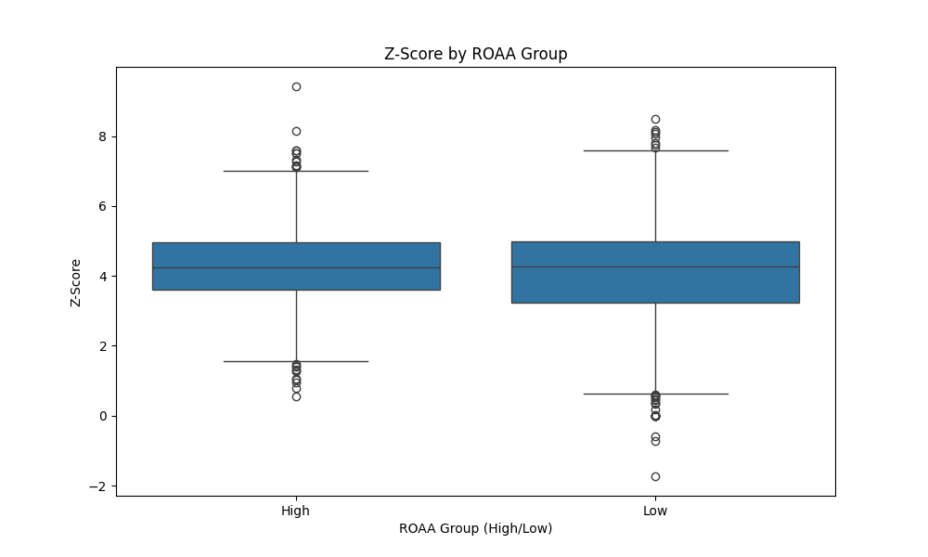

Fig 1: Box plots of z-scores with high and low ROAA groups

The box plot above visualizes Z-Scores based high and low ROAA. Each box represents interquartile range, which contains 50% of the data, whereas, the top and the bottom represent quartile 2 and quartile 1. The line inside the box is the median. The whiskers go from smallest to largest within 1.5 times of the interquartile range. The medians for both the Z-scores appear to be almost similar. This indicates that Z-Scores do not significantly differ from smaller and bigger banks. The interquartile range for both the banks is almost similar as well. But, we can infer, some banks with higher ROAA are more stable may be due to better risk management techniques.

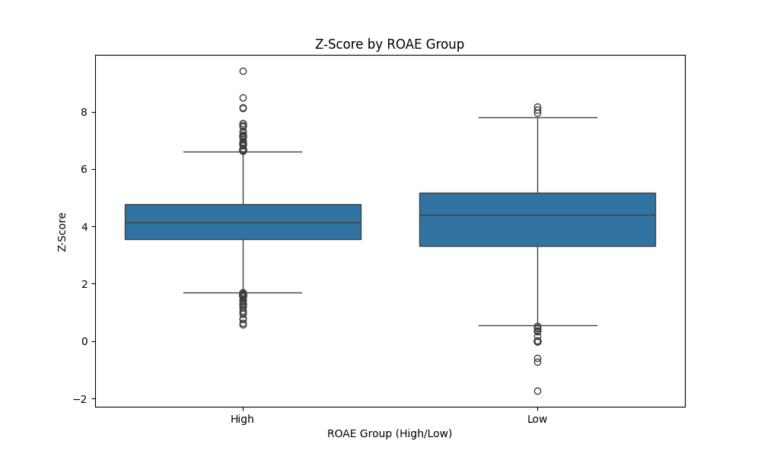

Fig 2: Box plots of z-scores with high and low ROAA groups

This is a box plot of z-scores and ROAE in high and low categories. Each box has interquartile range which contains 50% of the data. The top and bottom have the first and third quartile, the line in box is the median or the second quartile. The Z-scores for both high and low ROAE are almost similar between big banks and smaller banks. The interquartile ranges are also similar for both types of banks which suggests that volatility is also similar in both the cases. The outliers however show that banks with higher ROAE are significantly stable than banks with lower ROAE.

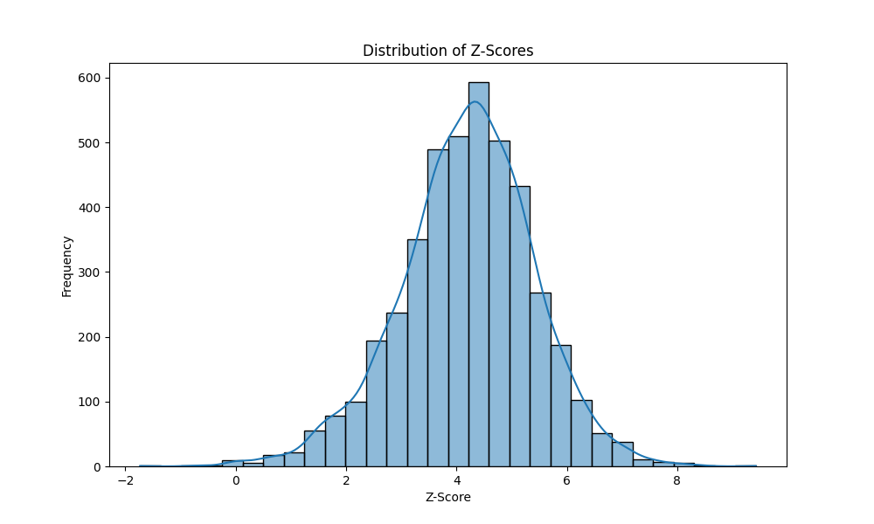

Fig 3: Distribution of Z-Scores

This is a histogram of z-scores across the dataset. The distribution follows a rough bell shaped curve which means z scores are approximately normally distributed which indicates z-scores are located in the centre with few banks with extremely high or low stability. The z-score is approximately 4 which indicates moderate stability. Z-scores range from -2 to 8 that means there is a lot of variability in the dataset. The distribution appears slightly right skewed which indicates that there are more banks with a higher z-score. The distribution is leptokurtic meaning most of the banks have z-score near 4 but there are few outliers with very high or low volatility.

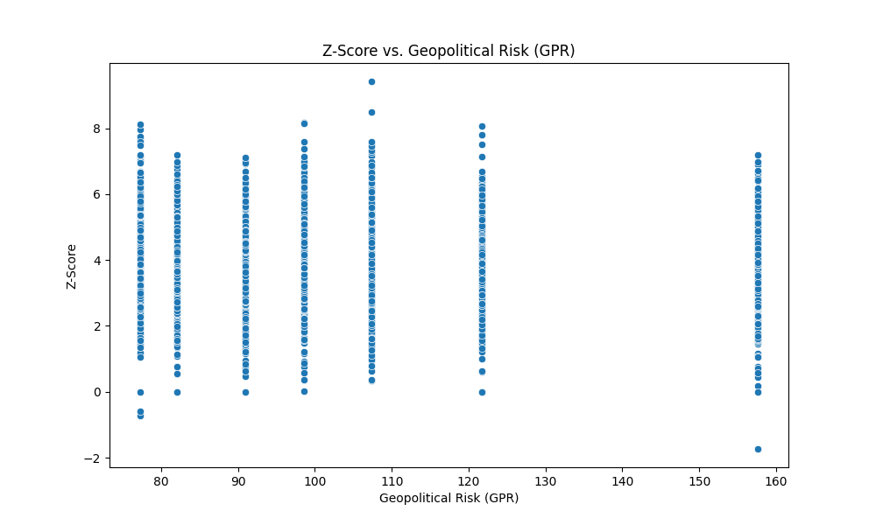

Fig 4: Scatter plot between z-score and GPR

This is the scatter plot between z-score and GPR. GPR is on x-axis and on the y-axis has the z-score. The data points are vertically grouped which indicates distinct geopolitical events corresponding to GPR levels during which the stability of banks vary. The z-scores again fall around -2 to 8, indicating significant variation of data. Most of the z-scores fall between 2 to 6, suggesting most of the banks are stable. The scatter plot also indicates a non-linear relationship between GPR and Z-scores. There are instances where higher GPR is associated with both high and low z-scores which tells us that some banks are stable while others are not. At higher GPR levels (more than 150), there are few banks with low approximately 0, indicating vulnerability, while there are banks with high z-scores at higher GPR levels shows a possible indication of better risk management techniques. There are few outliers, which suggests that there are banks which were severely affected by geopolitical distress.

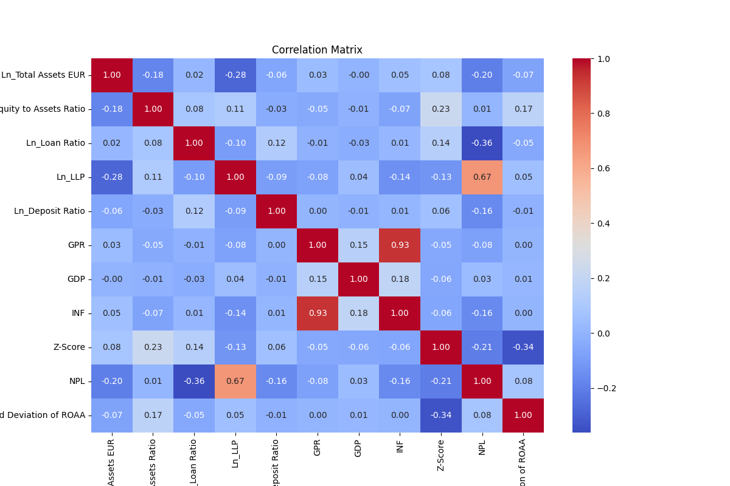

Fig 5: Heat map – Correlation Matix

This is a heatmap that helps us in visual understanding of corelation matrix of important variables in the Eurozone banking sector which helps us to explain relationships between different factors such as total assets, equity ratio, loan ratio, deposit ratio, geopolitical risk(GPR), Gross Domestic Product, Inflation, Z-Score, Non-performing loans, Return on average assets (ROAA).

5.7 Understanding the Matrix:

Correlation matrix is a statistic that helps us to show how variables are linearly interconnected, the range is from -1 to +1. -1 means strong negative relationship whereas, +1 indicates strong positive linear relationship. A value around 0 means there is no linear relationship but could have a non-linear relationship.

1. Total Assets v/s other variables:

* Z-Score: The correlation between total assets and z-score is weak positive (0.08) suggesting larger banks have higher z-scores, which indicates stronger stability. However, the lower correlation means total asset as a variable alone cannot justify bank stability.
* NPL: The correlation is moderately negative (-0.20) which gives us an insight that larger banks generally have lesser non-performing loans in their total loans which could be due to better risk management.

1. Equity to Assets:

* Z-Score: The positive correlation (0.23) with z-score shows that banks with higher equity ratios are more stable than the banks with lower ratio. Equity is a buffer against losses and higher ratio means higher shock absorbency.
* NPL: A moderate correlation (-0.36) means higher loan ratio give rise to lower non-performing loans which might be due to more number of loans against few non-performing loans.

1. Loan Loss Provision:

* NPL: There is strong positive correlation (0.67) which is intuitive and expected provisions are set for covering expected loss from non-performing loans which emphasises on importance of maintaining financial stability in the banks.
* Z-Score: The weak form negative correlation (-0.13) suggests that higher provisions might reduce the profitably as funds are allocated to provisions.

1. Loan Ratio:

* Z-score: Positive weak correlation (0.14) indicates that banks with higher loan ratios might be slightly stable. However, the relationship is not strong, which suggests that loan ratio might not be a significant influence on stability.

1. Geopolitical Risk:

* GDP and INF: GPR is positively correlated with both GDP(0.15) and inflation(0.93). The strong correlation with inflation should be noted which could mean geopolitical risk puts pressure on inflation during geopolitical events.
* Z-score: The weak negative correlation (-0.05) with z-score suggests that higher geopolitical risk is linked to lower bank stability. However, the relationship is not strong enough to make it the sole determinant of bank stability.
* NPL: Correlation with NPL is also mildly weak (-0.05), indicating geopolitical risk may not influence credit risk immediately but after a while as companies might set reserves for repaying back the loans.

1. Z-score v/s NPL and Standard Deviation of ROAA:

* The z-score has negative correlation with NPL (-0.21) and standard deviation of ROAA (-0.32) with indicates relationship between bank stability and credit quality. High z-score tends to lower NPL’S and volatility which is the expected behaviour as banks with higher credit quality loans tend to default on fewer loans.

5.8 Subsample analysis and findings:

To fully understand how different types of banks are affected by geopolitical risk, a subsample analysis is conducted in this study. It is both based on size (total assets) and profitability (ROAA and ROAE). The findings suggest a heterogenous response to GPR. It is observed that large banks usually insulate themselves better during geopolitical events. They still do experience shock the magnitude is lower compared to smaller banks. This finding supports the "franchise value effect" theory, which suggests larger banks tend to diversify themselves thus helping them to absorb shocks more efficiently than smaller banks as they have access to more capital.

5.9 Robustness Checks:

The robustness check and findings are tested through various methods. Use of GPR_Threats and GPR_Act show consistent results. The results show how geopolitical risk negatively impacts the bank’s performance, increases volatility and deteriorates asset quality. These results hold true across all the subsamples after considering potential endogeneity issue. Moreover, the use of Driscoll-Kraay standard errors for this study ensures that results are not prone to cross-sectional dependency and heteroskedasticity which helps in strengthen validity of this study.

1. Discussion:

The findings of this research provides us with substantial evidence the geopolitical risk has a significant impact on stability and profitability on the Eurozone banking. The analysis helps us understand that geopolitical risk, measured by GPR index exerts a downward impact on the performance on bank stability, increases volatility and increases the credit risk of the bank by the surge in the non-performing loans. These are findings are consistent across various subsamples highlighting the importance of banks to account and manage risk for geopolitical shocks.

One of the most notable relationships in this study the inverse relationship between geopolitical risk and Z-Scores which indicates bank stability. The Z-Score consists of profitability, leverage and risk in combination. When there is a geopolitical event that lowers the Z-score meaning the banks are more likely to fail during a geopolitical tension. In broader terms, we can associate the downfall of z-scores due to bad financial conditions in the economy. Geopolitical events can lead to trade disruptions, sanctions or change in government policies which may trigger banks to invest more in risk management thus reducing the profitability. To add further, geopolitical risk can mean higher interest rates, reduced willingness to lend, tighter credit conditions which can affect the bank’s performance.

The study also finds that the impact of geopolitical risk on bank stability is more when the perceived risks actually translate into actual geopolitical events. This means that any actual geopolitical event like terrorist attacks or conflicts affect banks more than mere news or threats. Threats have a different type of effect where it might initiate a sudden shift in investor sentiments which can lead to a sharp decline, increasing volatility and could cause issues with liquidity.

In terms of profitably, the GPR affects both ROAA and ROAE negatively indicating banks do not have a notable profit or may run into severe shortage during geopolitical tensions. This can be linked to various factors which could be geopolitical risk may increase the volatility in the markets which might reduce the profits for bank’s investments and trading activities. It also leads to deterioration of asset quality with the increase in NPL’s which can severely affect the banks in terms of credit risk. Bank’s may also have higher operational costs due to investing in better risk management and compliance to reduce the risk of failure.

6.1: Comparison with existing literature:

This study and its findings add to the existing literature on geopolitical risk, economics and bank’s performances. The existing studies have proven the negative effects of geopolitical risk on various aspects like the economy, change in investor sentiments including investing or trading and capital management (e.g., Caldara & Iacoviello, 2018; Bekaert et al., 2014). This research adds to providing a substantial evidence and to add how geopolitical risk affects banks and their stability particularly in the Eurozone.

A consistent pattern can be seen in all of the studies that have explored the external shocks on financial institutions like banks. For example, Laeven and Levine (2009) and Fang et al. (2014) have shown that there is potential financial distress during economic and political instability. This study adds and demonstrates the effects especially on Eurozone banking.

The positive relationship between the geopolitical risk and volatility in the returns is in adherence to literature on responses to uncertainty and financial markets. Studies by Bloom (2009) and Pastor and Veronesi (2012) have proved that any kind of uncertainty might lead to volatility in asset prices. This research is an extension of these findings and explains how banks are not immune to geopolitical risk.

The study further helps us to understand how geopolitical risk can extend itself to become credit risk. Existing literature shows us that geopolitical risk and political instability may lead to increase in credit risk and the unwillingness to lend (e.g., Reinhart & Rogoff, 2010; Gorton & Metrick, 2012). This study helps us understand more in terms of how it is affected in Eurozone.

6.2: Implications: Risk Management and Compliance

The findings of this research show how geopolitical risk may have implications for bank’s risk management, change in regulations and policy making. Bank’s need more robust risk management techniques to identify, asses and mitigate these types of risks. This might include diversification, improving stress testing to reduce exposures.

Increase of the volatility in returns due to geopolitical risks suggest that banks should manage liquidity in a better way. During geopolitical instability bank’s might find it difficult to pool liquidity. Banks should be proactive while assessing geopolitical risk and must have reliable information and adequate exit plans to avoid any kind of disruption. Bank is an institution that people trust and put their money into and a bank’s failure might improve distrust in people and on the economy. Therefore, bank’s must work to protect the investors and their sentiments.

From a regulatory standpoint, findings suggest that polices should be made to safeguard Eurozone’s economy. Regulators must closely monitor the exposure of banks outside their zone and must ensure each bank maintains a proper capital adequacy ratio. On a broader note, the economic policies should be reviewed. Maintaining good relationships and strategically opting out when needed is important. Diplomacy must be maintained and any conflict must have a peaceful resolution which might be difficult in practice but at least can be tried. Since the bank’s have shown positive Z-Score, ROAA and ROAE this means that banks especially in Eurozone may have better risk management techniques or are taking potentially high risk. If it is the case of taking high risk in political instability, it might affect the bank if the situation turns out not to be in favour of the bank’s decision.

6.3: Limitations and Scope for Improvement:

There are few limitations to study. It only focuses on time periods 2012-2023 and only particular to Eurozone which means that this might pose a limitation to generalize. Future research could include different regions and findings and comparative analysis of different regions. The use of GPR index might limit the study as it does not include any local news. This means any further research could try and experiment with other alternatives. Although panel regression is used for this study this study might be still prone to internal issues such as omitting variables or reverse causality. Any further study can include more variables to explain the cause-and-effect relationship. This study only explains direct relationship between bank performance and geopolitical risk but not the ripple effects or other effects. For example, investors may withdraw from a bank due to corporate governance and compliance issues and not geopolitical risk. Also, one must look at how banks behave in these kinds of situations, for example, larger banks might react different in comparison to mid-size or smaller banks. Future research can focus on differentiating sub-samples and then regressing to understand the bank’s behaviour even better. This study also motivates to bring together international relations and diplomacy and finance together as they go parallelly with each other. This study also opens up the idea of every nation creating its own geopolitical index which includes local and worldwide data to understand the complexity of geopolitics even more.

In conclusion, this study provides strong evidence that geopolitical risk may have a significant, negative impact on profitability of the banks in the Eurozone. The study highlights importance of risk management to prevent any effects of GPR. By improving techniques, banks can cushion themselves from external shocks and can improve their performance. This study needs to be taken further so that more complex situations can be analysed and to provide effective strategies to mitigate risks. This research is helpful for both practitioners and academics. Academically, this research sets a foundation for future research on geopolitical risk, markets and financial stability. Practically, this study provides insight on challenges and opportunities to manage geopolitical risk more efficiently especially in banking sector. By taking the challenges and transforming them into better risk management techniques can yield in better returns without taking higher risk.

1. Conclusion:

The study explores the Geopolitical risk and its impact on banking sector and stability of banks in Eurozone brings into limelight the complex relationship between geopolitics and performance of banking sector in the Eurozone. This study has help us analyse the geopolitical risk in terms of GPR index and effects on stability and profitability of the banks in Eurozone. With a detailed analysis using multiple models, it highlights that geopolitical risk can diminish banking performance with strong reflections on increase in non-performing loans and high volatility in the returns.

One of the key findings is the decline in z-scores in certain instances with an increasing trend in NPL’s which indicate exposure to more risks during geopolitical tensions. The banks become more vulnerable when mere threats transform themselves into actual events which lead to absolute chaos and volatility in the financial markets.

This study also helps us understand the negative impact of increasing GPR on Return of Average Assets and Return on Average Equity. The decline of profitability during periods of higher GPR have shown effects on asset quality by deterioration, increased market volatility and increase in operational costs due to enhancing risk management in turbulent times. The findings all align with the literature that already exists which helps us understand the adverse effects of external shocks like increased geopolitical risk exposure especially in the Eurozone which is one of the interconnected economies.

This research has also helped us understand how geopolitical risk can affect banks, regulations and policies. It also helps us understand the importance of risk management techniques which may include stress testing, portfolio diversification and improving ways to manage capital. In regulatory standpoint, the findings suggest that new policies must be planned for these kinds of events to promote financial stability. This can also mean that maintaining diplomatic relations and decreasing geopolitical tensions by peaceful resolution is important to keep the global financial markets healthy.

This study however has its own limitations as it only focuses on Eurozone banking and has no benchmark of other economies to compare to. The time period chosen for this study might limit us to generalize the findings for other time periods or other regions. This invites extension of this topic for future analysis for other regions and comparison with many economies so that it can help us understand the nuances of geopolitical risk and global markets. It also opens the idea of having a different geopolitical risk index for different regions which could potentially include the local political news and external news as well.

To conclude, this study has contributed to the growing interest in this field of geopolitics and economy. Though it is limited to Eurozone, it still gives us valuable insights on bank reactions to geopolitical risk. It highlights effects of geopolitical risk on bank’s performance and profitability, this study highlights the importance of vigilance and risk management in banking sector as the geopolitics becomes uncertain day by day.

References:

1. European Central Bank. (2023, February 24). The impact of the war on euro area economic activity [Blog post]. ECB Blog. <https://www.ecb.europa.eu/press/blog/date/2023/html/ecb.blog20230224~3b75362af3.en.html>
2. KPMG. (2022, May). Ukraine-Russia: Considerations for financial institutions [Web page]. KPMG Insights. <https://kpmg.com/xx/en/home/insights/2022/05/ukraine-russia-considerations-financial-institutions.html>
3. Bettin, G., Mensi, G. M., & Recchioni, M. C. (2023). Multifactor Risk Attribution Applied to Systemic, Climate and Geopolitical Tail Risks for the Eurozone Banking Sector. *Risks*, 11(10), 173. <https://doi.org/10.3390/risks11100173>
4. Maria-Eleni K. Agoraki, Georgios P. Kouretas & Nikiforos T. Laopodis (2022) Geopolitical risks, uncertainty, and stock market performance, Economic and Political Studies, 10:3, 253-265, DOI: 10.1080/20954816.2022.2095749
5. Khan, K., Khurshid, A., & Cifuentes-Faura, J. (2023). Is geopolitics a new risk to environmental policy in the European Union? Journal of Environmental Management. Advance online publication. <https://doi.org/10.1016/j.jenvman.2023.118868>
6. Van der Pijl, K. (2012). Securitisation as Class Formation—Finance, Geopolitics and the Eurozone Crisis. Paper presented at the conference A Comparative Political Economy of Securitization, University of Amsterdam, 15-16 October 2012. University of Sussex.
7. Goulard, S. 2022. The Impact of the US–China Trade War on the European Union.
8. Phan, D. H. B., Tran, V. T., & Iyke, B. N. (2022). Geopolitical risk and bank stability. *Finance Research Letters*, 46(Part B), 102453. <https://doi.org/10.1016/j.frl.2021.102453>.
9. Balli, F., & Louis, R. J. (2019). Geopolitical risks and bank stability in the Eurozone. International Review of Financial Analysis, 62, 180-189.
10. Buch, C. M., & Goldberg, L. S. (2021). Banking Globalization and Geopolitical Risk. Journal of Money, Credit and Banking, 53(1), 1-42.
11. De Haan, J., & Sturm, J.-E. (2020). Does central bank independence shield against the consequences of geopolitical risk? Evidence from the eurozone. European Journal of Political Economy, 61, 101854.
12. Hachem, K., & Hamidi Sahneh, M. (2018). Geopolitical risk and bank stability. Journal of Banking & Finance, 97, 225-240.
13. Cerutti, E., Claessens, S., & Laeven, L. (2020). Geopolitical Risks and Financial Stability. IMF Economic Review, 68(2), 287-327.
14. Claessens, S., Frost, J., & Turner, G. (2019). Managing and Financing Extreme Risks: Toward Banking and Insurance Union. IMF Working Papers, 19(146), 1-44.
15. Goodhart, C., & Segoviano, M. (2019). Banking Stability Measures: The Macroprudential Role of Central Banks. International Journal of Central Banking, 15(1), 287-327.
16. Trinh, H.H. and Tran, T.P., 2023. *Global Banking Systems, Financial Stability and Uncertainty: How have Countries Coped with Geopolitical Risk?* Massey University - School of Economics and Finance; Independent; Benedictine University. [online] Available at: <https://ssrn.com/abstract=4542972>. 23-24
17. Yıldırım, F. and Berkman, A.N., 2022. The impact of geopolitical risk index on the profitability performance of the banking sector. Journal of Turkish Social Sciences Research, 7(2), pp.89-100
18. Dieckelmann, D., Kaufmann, C., Larkou, C., McQuade, P., Negri, C., Pancaro, C. and Rößler, D., 2024. Turbulent times: geopolitical risk and its impact on euro area financial stability. Financial Stability Review, May 2024.
19. European Union (1992) Treaty on European Union (TEU) / Maastricht Treaty. Official Journal C 191, 29 July, p. 1-112.
20. Driscoll, John & Kraay, A.C.. (1998). Consistent covariance matrix estimation with spatially dependent data. Rev. Econ. Stat.. 80. 549-560.
21. Lefort, J.S. (2022) Ukraine economic shock. European Investment Bank, Available at: URL <https://www.eib.org/en/stories/ukraine-trade-inflation>
22. Iversen, T., Soskice, D., and Hope, D., 2016. The Eurozone and political economic institutions. *Annual Review of Political Science*, 19, pp.163-185. Available at: <https://doi.org/10.1146/annurev-polisci-022615-113243>
23. Caldara, D. and Iacoviello, M. (2018). Measuring Geopolitical Risk. American Economic Review, 108(4-5), pp.1194-1225. DOI: 10.1257/aer.20170502.
24. Bekaert, G., Harvey, C. R. and Lundblad, C. (2014). Political Risk Spreads. Journal of International Business Studies, 45(4), pp.471-493. DOI: 10.1057/jibs.2014.4.
25. Laeven, L. and Levine, R. (2009). Bank Governance, Regulation, and Risk Taking. Journal of Financial Economics, 93(2), pp.259-275. DOI: 10.1016/j.jfineco.2008.09.003.
26. Pastor, L. and Veronesi, P. (2012). Uncertainty about Government Policy and Stock Prices. The Journal of Finance, 67(4), pp.1219-1264. DOI: 10.1111/j.1540-6261.2012.01746.x.
27. Reinhart, C. M. and Rogoff, K. S. (2010). Growth in a Time of Debt. American Economic Review, 100(2), pp.573-578. DOI: 10.1257/aer.100.2.573.
28. Gorton, G. and Metrick, A. (2012). Getting Up to Speed on the Financial Crisis: A One-Weekend-Reader’s Guide. Journal of Economic Literature, 50(1), pp.128-150. DOI: 10.1257/jel.50.1.128.
29. Fang, V. W., Tian, X. and Tice, S. (2014). Does Stock Liquidity Enhance or Impede Firm Innovation? The Journal of Finance, 69(5), pp.2085-2125. DOI: 10.1111/jofi.12187.
30. Bloom, N. (2009). The Impact of Uncertainty Shocks. Econometrica, 77(3), pp.623-685. DOI: 10.3982/ECTA6248.